4.8.8 Tessellation
# Source: AI Source: Provided by: [Data Path: Persons Table -> ID Column: 1, Name_En Column: Motasem Essam] -> From: [ChatGPT] on [7/25/2026]
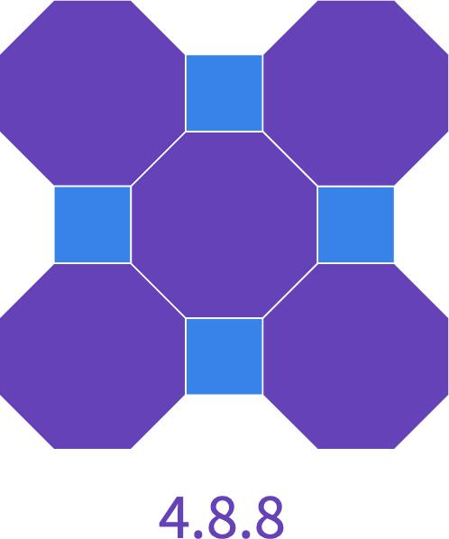
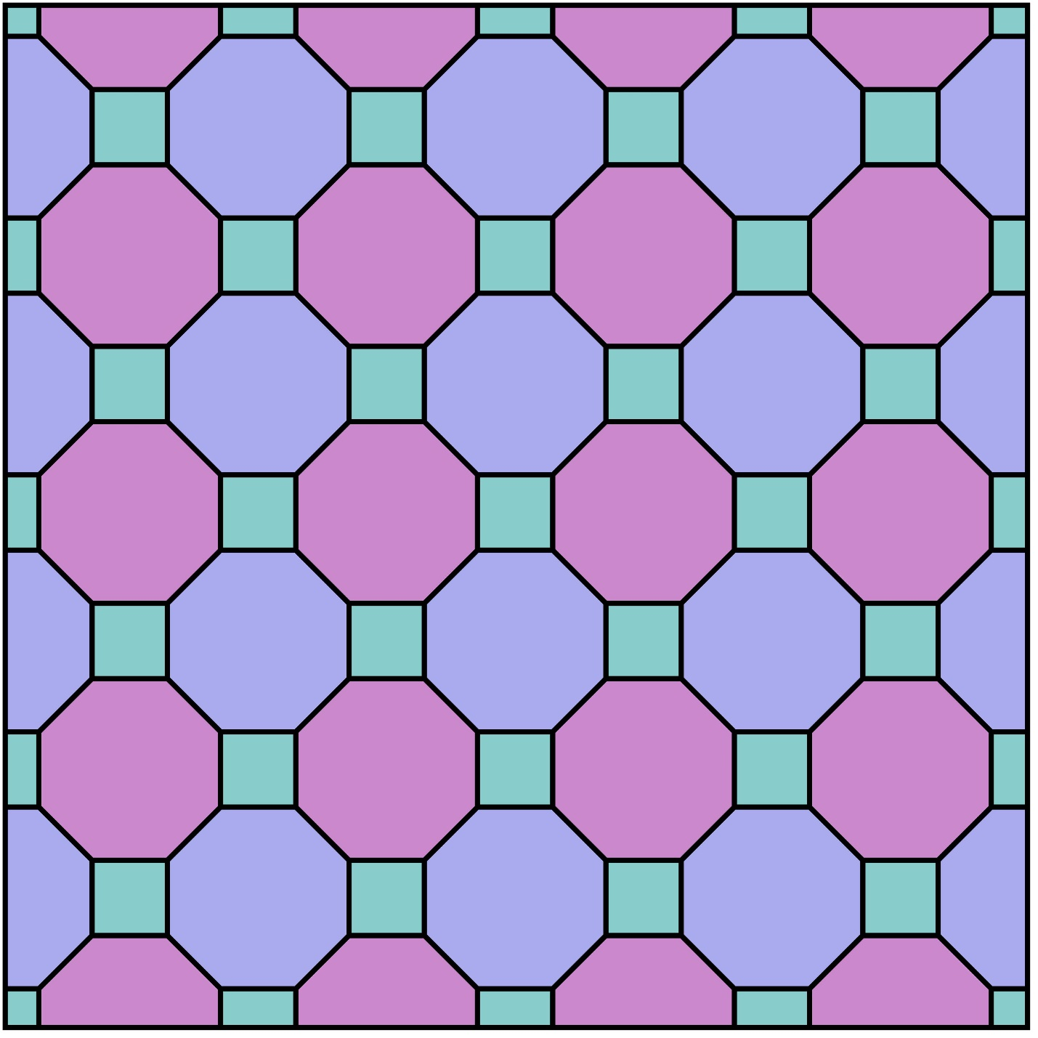
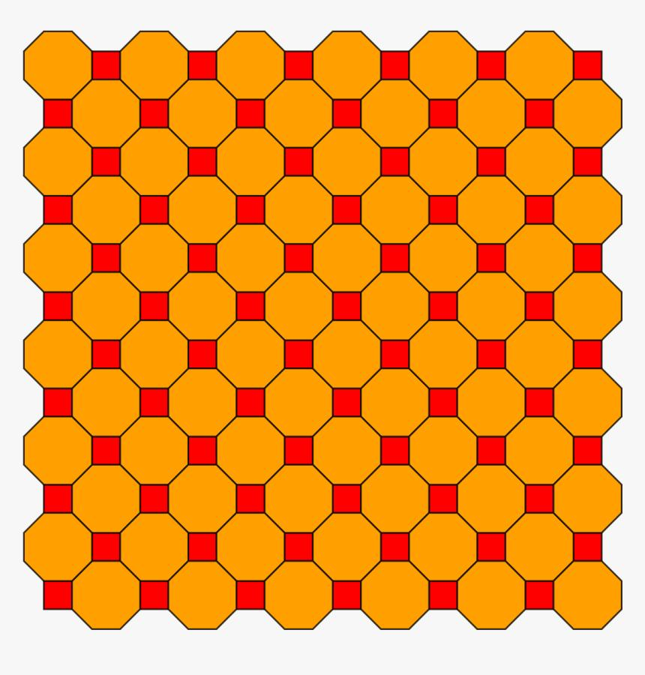
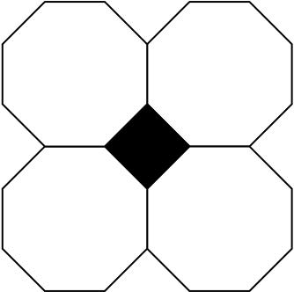

Definition
# Source: AI Source: Provided by: [Data Path: Persons Table -> ID Column: 1, Name_En Column: Motasem Essam] -> From: [ChatGPT] on [7/25/2026]
The 4.8.8 tessellation is a semi-regular (Archimedean) tessellation of the Euclidean plane composed of squares and regular octagons.
Its vertex configuration is:
$$\boxed{4.8.8}$$
This means that, around every vertex, the polygons occur in the cyclic order:
Square → Octagon → Octagon

Classification
# Source: AI Source: Provided by: [Data Path: Persons Table -> ID Column: 1, Name_En Column: Motasem Essam] -> From: [ChatGPT] on [7/25/2026]
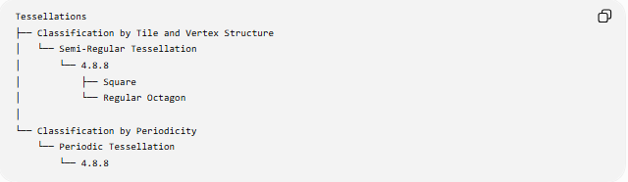
Tessellations
├── Classification by Tile and Vertex Structure
│ └── Semi-Regular Tessellation
│ └── 4.8.8
│ ├── Square
│ └── Regular Octagon
│
└── Classification by Periodicity
└── Periodic Tessellation
└── 4.8.8
Therefore:
$$\boxed{\text{4.8.8 is Semi-Regular and Periodic}}$$

Fundamental Elements
# Source: AI Source: Provided by: [Data Path: Persons Table -> ID Column: 1, Name_En Column: Motasem Essam] -> From: [ChatGPT] on [7/25/2026]
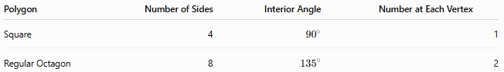
Polygon | Number of Sides | Interior Angle | Number at Each Vertex
Square | 4 | $${90}^{∘}$$ | 1
Regular Octagon | 8 | $${135}^{∘}$$ | 2
Thus, three polygons meet at every vertex:
$$\boxed{1\text{ square}+2\text{ octagons}}$$

Vertex Angle Verification
# Source: AI Source: Provided by: [Data Path: Persons Table -> ID Column: 1, Name_En Column: Motasem Essam] -> From: [ChatGPT] on [7/25/2026]
The interior angle of a square is:
$${90}^{∘}$$
The interior angle of a regular octagon is:
$$\frac{\left(8-2\right){180}^{∘}}{8}={135}^{∘}$$
Therefore, around each vertex:
$${90}^{∘}+{135}^{∘}+{135}^{∘} \\ =\boxed{{360}^{∘}}$$
So the polygons fit together exactly without gaps or overlaps.

Basic Structure
# Source: AI Source: Provided by: [Data Path: Persons Table -> ID Column: 1, Name_En Column: Motasem Essam] -> From: [ChatGPT] on [7/25/2026]
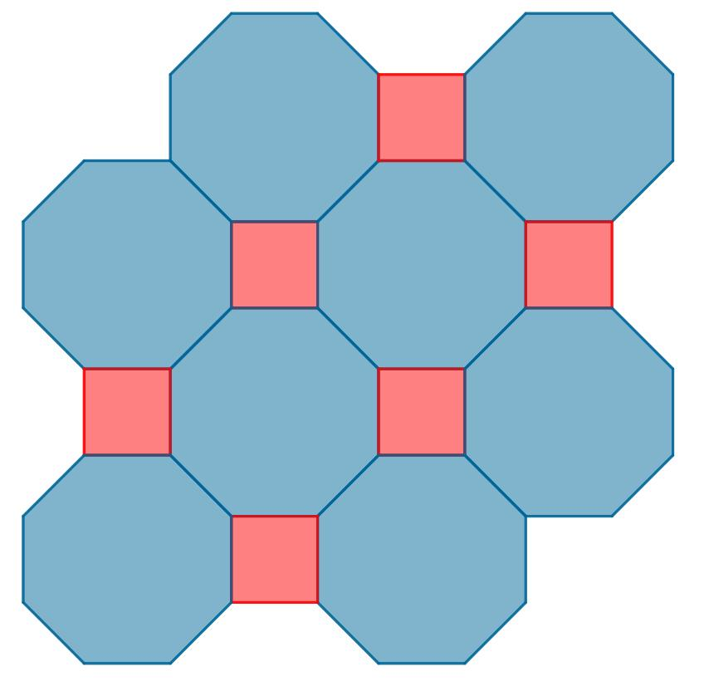
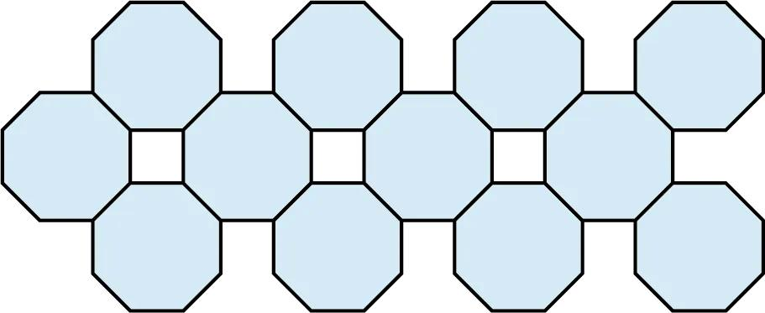
The pattern consists of large regular octagons separated by small regular squares.
The squares fill the gaps that would otherwise occur between neighboring octagons.

Vertex Configuration
# Source: AI Source: Provided by: [Data Path: Persons Table -> ID Column: 1, Name_En Column: Motasem Essam] -> From: [ChatGPT] on [7/25/2026]
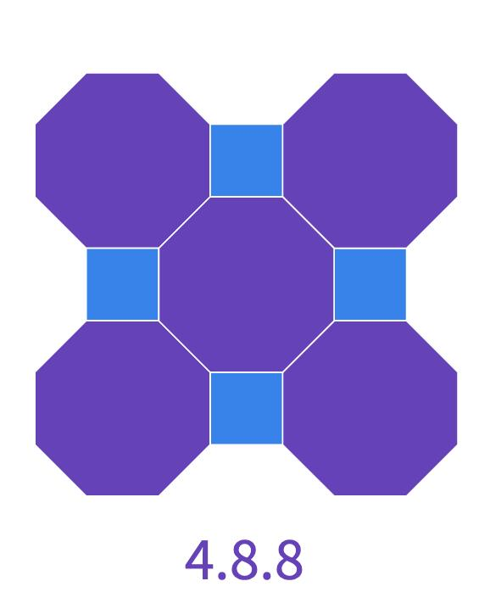
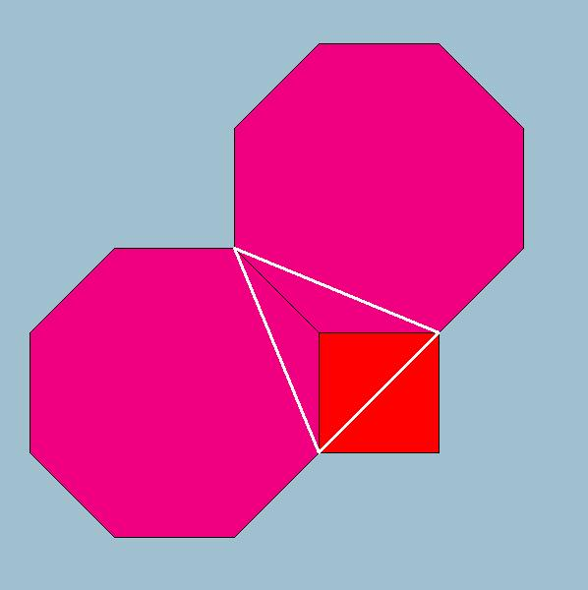
The notation
$$\boxed{4.8.8}$$
records the number of sides of the polygons encountered cyclically around a vertex:
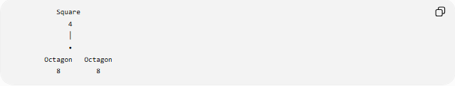
Square
4
│
•
Octagon Octagon
8 8
The cyclic sequence is:
$$\boxed{4→8→8}$$

Why It Is Semi-Regular
# Source: AI Source: Provided by: [Data Path: Persons Table -> ID Column: 1, Name_En Column: Motasem Essam] -> From: [ChatGPT] on [7/25/2026]
The $4.8.8$tessellation satisfies the defining properties of a semi-regular tessellation:
- All tiles are regular polygons.
- Two different polygon types are used.
- The same vertex configuration occurs at every vertex.
- The polygons meet edge-to-edge.
- There are no gaps or overlaps.
Therefore:
$$\boxed{\text{4.8.8 is a Semi-Regular Tessellation}}$$

Why It Is Not Regular
# Source: AI Source: Provided by: [Data Path: Persons Table -> ID Column: 1, Name_En Column: Motasem Essam] -> From: [ChatGPT] on [7/25/2026]
A regular tessellation uses only one type of regular polygon.
The $4.8.8$tessellation uses:
- Squares
- Regular octagons
Therefore:
$$\boxed{\text{4.8.8 is not a Regular Tessellation}}$$

Periodicity
# Source: AI Source: Provided by: [Data Path: Persons Table -> ID Column: 1, Name_En Column: Motasem Essam] -> From: [ChatGPT] on [7/25/2026]
The pattern repeats throughout the Euclidean plane through translations.
Therefore:
$$\boxed{\text{4.8.8 is Periodic}}$$
Its combined classification is:
$$\boxed{\text{Semi-Regular + Periodic}}$$

Mathematical Representation
# Source: AI Source: Provided by: [Data Path: Persons Table -> ID Column: 1, Name_En Column: Motasem Essam] -> From: [ChatGPT] on [7/25/2026]
For a regular $n$-gon:
$$θ_{n}=\frac{\left(n-2\right){180}^{∘}}{n}$$
For the square:
$$θ_{4}={90}^{∘}$$
For the regular octagon:
$$θ_{8}={135}^{∘}$$
Therefore:
$$θ_{4}+2θ_{8}={360}^{∘} \\ \boxed{{90}^{∘}+2\left({135}^{∘}\right)={360}^{∘}}$$

Equivalent Compact Notation
# Source: AI Source: Provided by: [Data Path: Persons Table -> ID Column: 1, Name_En Column: Motasem Essam] -> From: [ChatGPT] on [7/25/2026]
The configuration can also be written as:
$$\boxed{{4.8}^{2}}$$
This indicates:
- $4$→ one square
- $8^{2}$→ two octagons
The expanded notation
$$\boxed{4.8.8}$$
shows the cyclic order explicitly.

Important Structural Feature
# Source: AI Source: Provided by: [Data Path: Persons Table -> ID Column: 1, Name_En Column: Motasem Essam] -> From: [ChatGPT] on [7/25/2026]
Two regular octagons alone cannot meet edge-to-edge around a vertex because:
$${135}^{∘}+{135}^{∘}={270}^{∘}$$
This leaves:
$${360}^{∘}-{270}^{∘}={90}^{∘}$$
which is exactly the interior angle of a square.
Thus:
$$\boxed{{135}^{∘}+{135}^{∘}+{90}^{∘}={360}^{∘}}$$
This explains why the square fits perfectly between the two octagons at each vertex.

Comparison with $3.12.12$
# Source: AI Source: Provided by: [Data Path: Persons Table -> ID Column: 1, Name_En Column: Motasem Essam] -> From: [ChatGPT] on [7/25/2026]
Both are semi-regular tessellations with three polygons at each vertex.
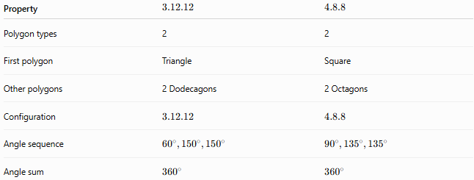
Property | $$3.12.12$$ | $$4.8.8$$
Polygon types | 2 | 2
First polygon | Triangle | Square
Other polygons | 2 Dodecagons | 2 Octagons
Configuration | $$3.12.12$$ | $$4.8.8$$
Angle sequence | $${60}^{∘},{150}^{∘},{150}^{∘}$$ | $${90}^{∘},{135}^{∘},{135}^{∘}$$
Angle sum | $${360}^{∘}$$ | $${360}^{∘}$$

Comparison with $4.6.12$
# Source: AI Source: Provided by: [Data Path: Persons Table -> ID Column: 1, Name_En Column: Motasem Essam] -> From: [ChatGPT] on [7/25/2026]
Both have a square as one of their tiles and three polygons meeting at every vertex.
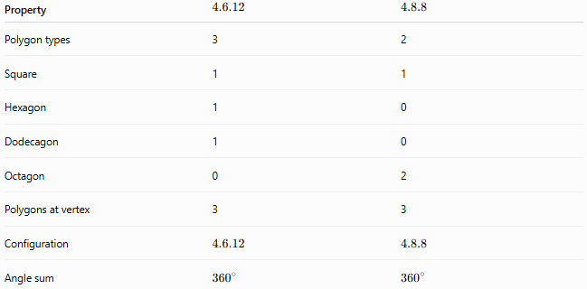
Property | $$4.6.12$$ | $$4.8.8$$
Polygon types | 3 | 2
Square | 1 | 1
Hexagon | 1 | 0
Dodecagon | 1 | 0
Octagon | 0 | 2
Polygons at vertex | 3 | 3
Configuration | $$4.6.12$$ | $$4.8.8$$
Angle sum | $${360}^{∘}$$ | $${360}^{∘}$$

Key Properties
# Source: AI Source: Provided by: [Data Path: Persons Table -> ID Column: 1, Name_En Column: Motasem Essam] -> From: [ChatGPT] on [7/25/2026]
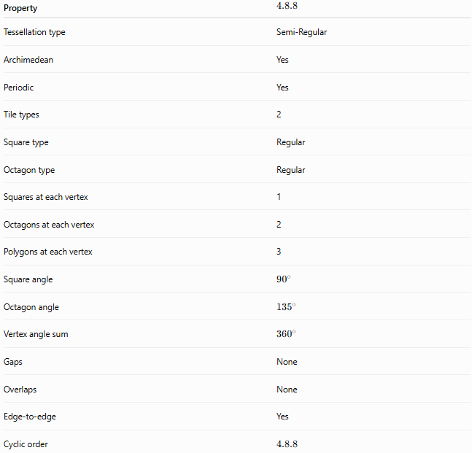
Property | $$4.8.8$$
Tessellation type | Semi-Regular
Archimedean | Yes
Periodic | Yes
Tile types | 2
Square type | Regular
Octagon type | Regular
Squares at each vertex | 1
Octagons at each vertex | 2
Polygons at each vertex | 3
Square angle | $${90}^{∘}$$
Octagon angle | $${135}^{∘}$$
Vertex angle sum | $${360}^{∘}$$
Gaps | None
Overlaps | None
Edge-to-edge | Yes
Cyclic order | $$4.8.8$$

Relationship to the Eight Semi-Regular Tessellations
# Source: AI Source: Provided by: [Data Path: Persons Table -> ID Column: 1, Name_En Column: Motasem Essam] -> From: [ChatGPT] on [7/25/2026]
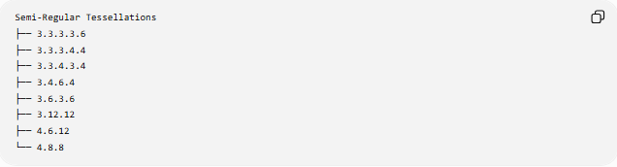
Semi-Regular Tessellations
├── 3.3.3.3.6
├── 3.3.3.4.4
├── 3.3.4.3.4
├── 3.4.6.4
├── 3.6.3.6
├── 3.12.12
├── 4.6.12
└── 4.8.8
The 4.8.8 tessellation is the final configuration in the standard set of 8 Archimedean tessellations.

Key Points
# Source: AI Source: Provided by: [Data Path: Persons Table -> ID Column: 1, Name_En Column: Motasem Essam] -> From: [ChatGPT] on [7/25/2026]
- $4.8.8$is a semi-regular (Archimedean) tessellation.
- It uses squares and regular octagons.
- Three polygons meet at every vertex.
- The vertex configuration is:
$$\boxed{4.8.8}$$
- Each vertex contains:
  - 1 square
  - 2 octagons
- Their angles are:
$${90}^{∘}, {135}^{∘}, {135}^{∘}$$
- Their sum is:
$$\boxed{{360}^{∘}}$$
- It is also periodic.
- Its compact form is:
$$\boxed{{4.8}^{2}}$$

Conclusion
# Source: AI Source: Provided by: [Data Path: Persons Table -> ID Column: 1, Name_En Column: Motasem Essam] -> From: [ChatGPT] on [7/25/2026]
The 4.8.8 tessellation is a semi-regular, periodic tessellation composed of regular squares and regular octagons. At every vertex, one square and two octagons meet in the cyclic configuration
$$\boxed{4.8.8}$$
and their interior angles satisfy
$$\boxed{{90}^{∘}+{135}^{∘}+{135}^{∘}={360}^{∘}}$$
allowing the polygons to cover the Euclidean plane completely without gaps or overlaps.

